- INSERT OPERATIONS
Ques.1=> What is the purpose of insertOne() in MongoDB?
Ans.1=> Purpose of insertOne() command is to insert one single document into a collection.
Ques.2=> Write a MongoDB command to insert a single document into a collection.
Ans.2=> db.trips.insertOne({ name: "Pranjal", destination: "Manali", Budget : 20000 })
Ques.3=> How does MongoDB behave if the collection does not exist while using insertOne()?
Ans.3=> In this situation, MongoDB automatically creates the collection and inserts the document.
Ques.4=>What is insertMany() and how is it different from insertOne()?
Ans.4=> insertMany() - Inserts multiple documents at once.
Difference : • insertOne() → Inserts one document.
• insertMany() → Insert multiple documents.
Ques.5=> What happens if one document fails during insertMany() execution?
Ans.5=> By default, MongoDB stops inserting further documents.

- UPDATE OPERATIONS
Ques.6=> What is the difference between updateOne() and updateMany()?
Ans.6=> Difference between updateOne() and updateMany():
• updateOne() → updates first matching document
• updateMany() → updates all matching documents
Ques.7=> Write a command to update only one document’s field in MongoDB.
Ans.7=> db.trips.updateOne({ name: "Pranjal" }, destination: "Manali", Budget : 20000,{ $set: { Budget: 25000 } })
Ques.8=>How do you update multiple documents at the same time in MongoDB?
Ans.8=> db.data.updateMany({ city: "Pune" }, { $set: { active: true } })
Ques.9=> What happens if the filter condition in updateOne() matches multiple documents?
Ans.9=> Only one document is updated.
Ques.10=>What update operator is used to modify specific fields without replacing the entire document?
Ans.10=> Operator-> $set

- Add Date (Current Date)
Ques.11=> How do you add the current date to a document while inserting data?
Ans.11=> By using new Date().
Ques.12=> Which MongoDB operator is equivalent to SQL CURDATE()?
Ans.12=> new Date()
Ques.13=> Write a command to add the current date to all existing documents.
Ans.13=> db.orders.updateMany({}, { $currentDate: { updatedAt: true } })
Ques.14=> What is the difference between using new Date() and $currentDate?
Ans.14=> Difference between new Date() and $currentDate:
• new Date() → adds date manually.
• $currentDate → MongoDB automatically sets current date.

- Delete Operations
Ques.15=>What is the difference between deleteOne() and deleteMany()?
Ans.15=> Difference between deleteOne() and deleteMany():
• deleteOne() → deletes one document.
• deleteMany() → deletes multiple documents.
Ques.16=> Write a MongoDB command to delete a single document.
Ans.16=> db.data.deleteOne({ name: "Shreya" })
Ques.17=>What happens if the filter in deleteMany() is empty {}?
Ans.17=> All documents in the collection are deleted.

- Drop Operations
Ques.18=> How do you drop a collection (table) in MongoDB?
Ans.18=> Command-> db.trips.drop()
Ques.19=> What is the command to drop an entire database in MongoDB?
Ans.19=> Command-> db.dropDatabase()
Ques.20=> What is the difference between deleteMany({}) and drop()?
Ans.20=> Difference between deleteMany({}) and drop():
• deleteMany({}) → deletes all documents, collection remains
• drop() → deletes collection + structure

MongoDB Practical Questions (CRUD)
- Insert One (Practical)
Ques.21=> Insert a student record with name, course, and year.
Ans.21=> db.students.insertOne({ name : "Pranjal", course : "Computer Science" , year : 2021});
db.students.find();
Ques.22=> Insert an employee document with name, role, salary, and joining date.
Ans.22=> db.employee.insertOne({ name : 'Pranjal' , role: 'Software Engineer' , salary : 100000 , joiningDate : ISODate('2025-11-21')});
db.employee.find();
Ques.23=> Create a product document with name, price, and category.
Ans.23=> db.packages.insertOne({name:"Manali Trip", price: 10000, category: "Hill Station"})
db.packages.find();

- InsertMany (Practical)
Ques.24=> Insert at least 5 user records into a collection.
Ans.24=> db.users.insertMany([
{ name: "Pranjal" , city: "Pune" },
{ name: "Shreya" , city: "Delhi" },
{ name: "Anushka" , city: "Jaipur" },
{ name: "Sachin" , city: "Chandigarh" },
{ name: "Anjali" , city: "Mumbai" }
]);
db.users.find();
Ques.25=>Insert multiple products belonging to different categories.
Ans.25=>db.products.insertMany([
{ name: "iphone16" , price: 85000, category:"Electronics" },
{ name: "Watch" , price: 10000, category:"Accessories" },
{ name: "shoes" , price: 7000, category:"Footwear" }
]);
db.products.find();
Ques.26=> Insert many orders with orderId, customerName, and totalAmount.
Ans.26=> db .order.insertMany([
{order_Id : 1024 , cust_name: "Shreya" , Total_Amount : 2000},
{order_Id : 1025 , cust_name: "Riya" , Total_Amount : 3000},
{order_Id : 1026 , cust_name: "Mitali" , Total_Amount : 4000},
{order_Id : 1024 , cust_name: "Samiksha" , Total_Amount : 5000},
{order_Id : 1024 , cust_name: "Trpti" , Total_Amount : 6000}
]);
db.order.find();

- UpdateOne (Practical)
Ques.27=> Update the salary of a single employee.
Ans.27=> db .employee.insertMany([
{emp_Id : 1024 , name: "Shreya" , Salary: 100000},
{emp_Id : 1025 , name: "Riya" , Salary : 200000},
{emp_Id : 1026 , name: "Mitali" , Salary: 100000},
{emp_Id : 1024 , name: "Samiksha" , Salary: 300000},
{emp_Id : 1024 , name: "Trpti" , Salary : 400000}
]);
db.employee.updateOne(
{name: "Mitali"},
{$set: {Salary : 500000}}
);
db.employee.find();
Ques.28=> Add a new field status to one specific user.
Ans.28=> db.users.insertMany([
{ name: "Pranjal" , city: "Pune" },
{ name: "Shreya" , city: "Delhi" },
{ name: "Priya" , city: "Jaipur" }
]);
db.users.updateOne(
{name:"Shreya"},{$set:{status:"Active"}});
db.users.find();
Ques.29=> Change the city of one customer.
Ans.29=> db.users.insertMany([
{ name: "Pranjal" , city: "Pune" },
{ name: "Shreya" , city: "Delhi" },
{ name: "Anushka" , city: "Jaipur" },
{ name: "Sachin" , city: "Chandigarh" },
{ name: "Anjali" , city: "Mumbai" }
]);
db.users.updateOne(
{name : "Shreya"} ,
{$set :{city: "Mumbai"}}
);
db.users.find();

- Update Many(Practical)
Ques.30=> Add a field updatedDate with the current date to all records.
Ans.30=> db.bookings.insertMany([
{ name: "Pranjal" , city: "Pune",Amount : 5000 },
{ name: "Shreya" , city: "Delhi",Amount : 5000},
{ name: "Anushka" , city: "Jaipur",Amount : 3000 },
{ name: "Sachin" , city: "Chandigarh",Amount : 6000},
{ name: "Anjali" , city: "Mumbai",Amount : 7000 }
]);
db.bookings.updateMany(
{} ,
{$currentDate :{updatedDate: true}}
);
db.bookings.find();
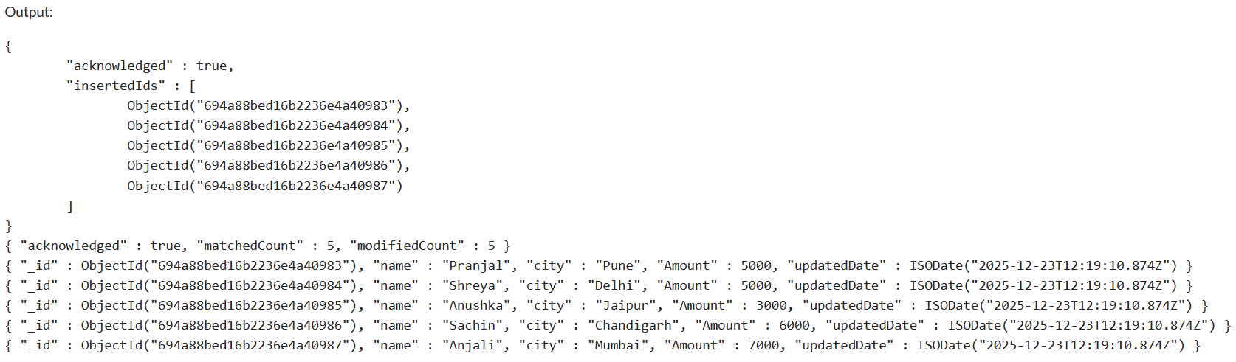
Ques.31=> Increase the price of all products in a specific category.
Ans.31=> db.products.insertMany([
{ name: "iphone16" , price: 85000, category:"Electronics" },
{ name: "Watch" , price: 10000, category:"Electronics" },
{ name: "shoes" , price: 7000, category:"Footwear" }
]);
db.products.updateMany({category:"Electronics"},
{$inc:{price:5000}});
db.products.find();
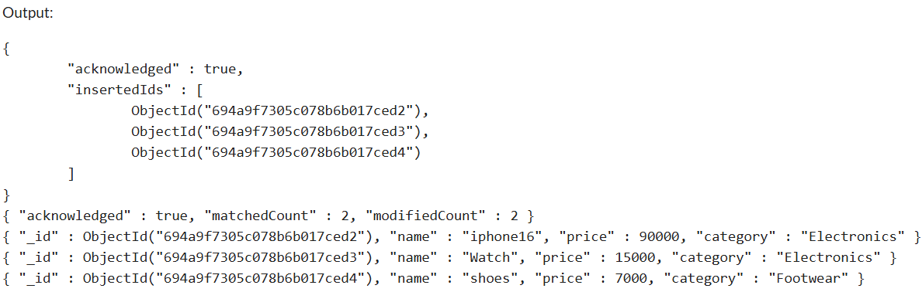
Ques.32=> Add a new field country to all users.
Ans.32=> db.users.insertMany([
{ name: "Pranjal" , city: "Pune" },
{ name: "Shreya" , city: "Delhi" },
{ name: "Priya" , city: "Jaipur" }
]);
db.users.updateMany({},{$set:{country: 'India}});
db.users.find();
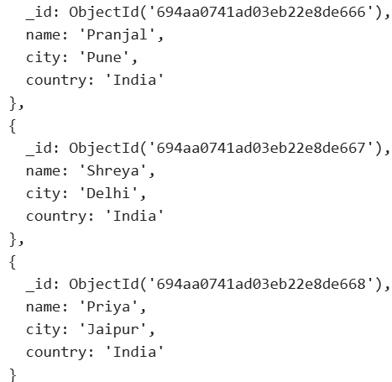

- Add Date (Practical)
Ques.33=> Insert a document with the current date using MongoDB.
Ans.33=> use dateDB;
db.records.insertMany([
{ name: "Event A" , year: "2019" },
{ name: "Event B" , year: "2020" },
{ name: "Event C" , year: "2021" }
]);
db.records.insertOne({
name: "Event D",
city : new Date()
});
db.records.find();
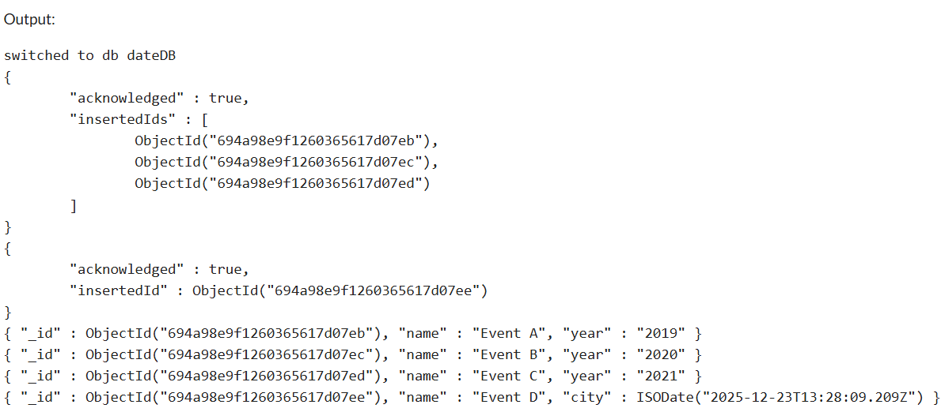
Ques.34=>Update all documents by adding today’s date.
Ans.34=> db.records.insertMany([
{ name: "Event A" , year: "2019" },
{ name: "Event B" , year: "2020" },
{ name: "Event C" , year: "2021" }
]);
db.records.updateMany({},
{$set: {year : ISODate("2026-01-01")}
});
db.records.find();
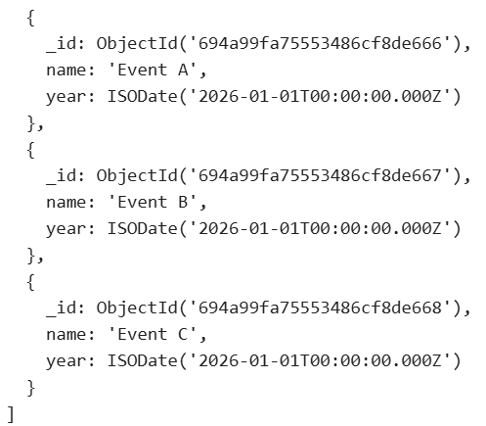
Ques.35=> Convert a numeric year field into a date field.
Ans.35=> db.event.insertMany([
{eventname: "Workshop", year: 2021},
{eventname: "Seminar", year: 2022},
{eventname: "Conference", year: 2023},
{eventname: "TechFest", year: 2023}
]);
db.event.updateMany(
{},
{$set:{year:ISODate("2026-01-01")}}
);
db.event.find();
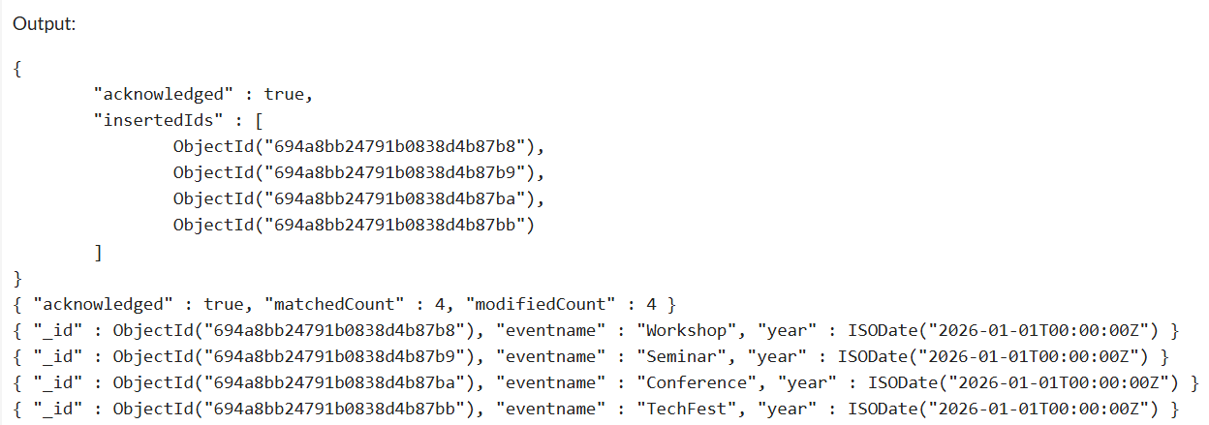

- DeleteOne(Practical)
Ques.36=> Delete a user whose name is "Ali".
Ans.36=> db.users.insertMany([
{ name: "Pranjal" , city: "Pune" },
{ name: "Shreya" , city: "Delhi" },
{ name: "Ali" , city: "Jaipur" },
]);
db.users.deleteOne({name:"Ali"});
db.users.find();
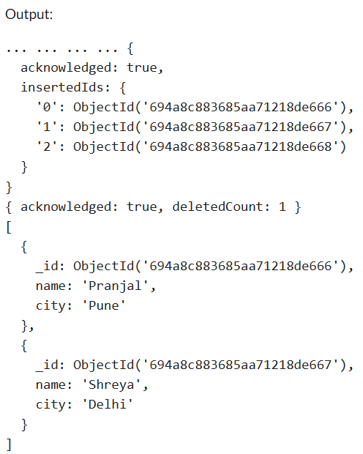
Ques.37=>Remove one product with a specific productId.
Ans.37=> db .products.insertMany([
{Pro_Id : 1024 , cust_name: "Shreya" , Total_Amount : 2000},
{Pro_Id : 1025 , cust_name: "Riya" , Total_Amount : 3000},
{Pror_Id : 1026 , cust_name: "Mitali" , Total_Amount : 4000}
]);
db.products.deleteOne({Pro_Id:1025});
db.products.find();
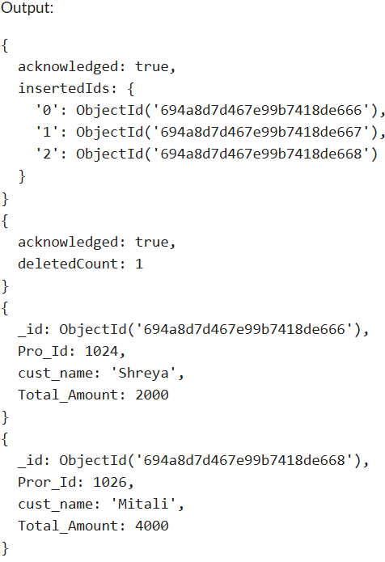
6. DeleteMany (Practical)
Ques.38=>Delete all users from a particular city.
Ans.38=> db.users.insertMany([
{ name: "Pranjal" , city: "Pune" },
{ name: "Shreya" , city: "Mumbai" },
{ name: "Anushka" , city: "Mumbai" },
{ name: "Sachin" , city: "Chandigarh" },
{ name: "Anjali" , city: "Mumbai" }
]);
db.users.deleteMany({city:"Mumbai"});
db.users.find();
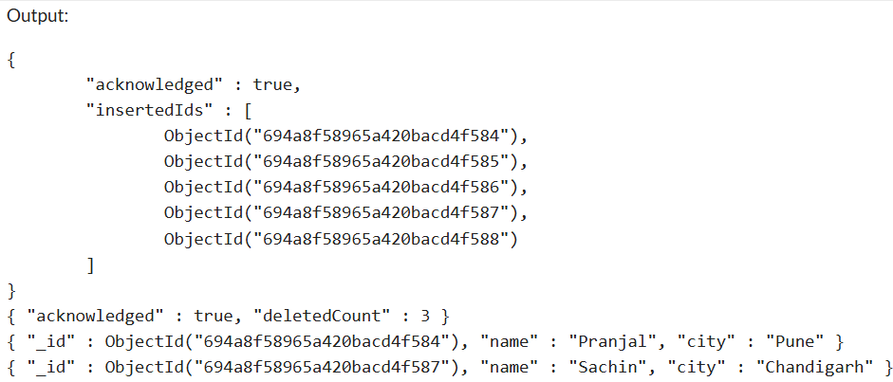
Ques.39=> Delete all records where the year is less than 2020.
Ans.39=> db.event.insertMany([
{eventname: "Workshop", year: 2021},
{eventname: "Seminar", year: 2019},
{eventname: "Conference", year: 2017},
{eventname: "TechFest", year: 2023}
]);
db.event.deleteMany({year:{$lt:2020}});
db.event.find();
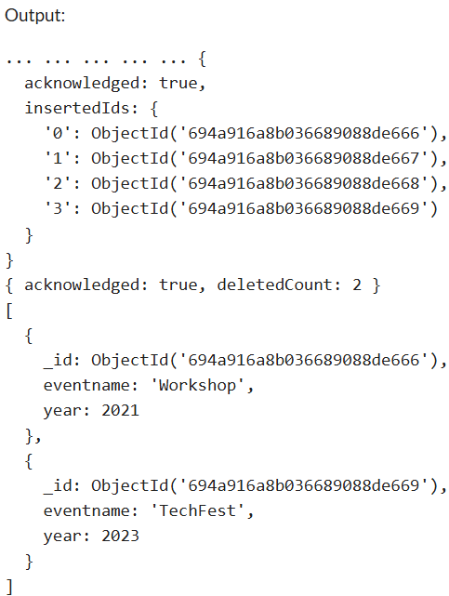
8. Drop Operations (Practical)
Ques.40=>Drop a collection named students.
Ans.40=> db.users.insertMany([
{ name: "Pranjal" , city: "Pune" },
{ name: "Shreya" , city: "Delhi" },
{ name: "Priya" , city: "Jaipur" }
]);
db.users.find();
db.users.drop();
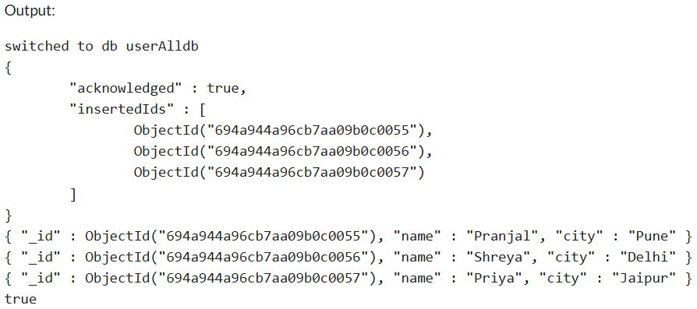
Ques.41=> Drop the current database.
Ans.41=> use userAlldb;
db.dropDatabase(); 